**Name: -** Abdul Quddos **Class: -** BSE IV-B **Date: -** 23/06/2022 **Enrollment: -** 02-131202-033 **Registration: -** 69986

LAB 13 EVALUATION

Q: Create a restful web service or rest api and show the results of get , post , put and delete functions on postman (api testing application) **Solution: -**

public class Friend

{

internal int id;

public string firstname { get; set; } public string lastname { get; set; } public string location { get; set; }

public DateTime dateOfHire { get; set; }

public Friend()

{

}

public Friend(int id,string firstname, string lastname, string location, DateTime dateOfHire)

{

this.id = id;

this.firstname = firstname; this.lastname = lastname; this.location = location;

this.dateOfHire = dateOfHire;

}

}

[Route("api/[controller]")] [ApiController]

public class FriendController : ControllerBase

{

List<Friend> friends = new List<Friend>();

public FriendController()

{

friends.Add(new Friend(1,"Kindson", "Munonye", "Budapest", DateTime.Today)); friends.Add(new Friend(2,"Oleander", "Yuba", "Nigeria", DateTime.Today)); friends.Add(new Friend(3,"Saffron", "Lawrence", "Lagos", DateTime.Today)); friends.Add(new Friend(4,"Jadon", "Munonye", "Asaba", DateTime.Today)); friends.Add(new Friend(5,"Solace", "Okeke", "Oko", DateTime.Today));

}

// GET: api/<FriendController>

[HttpGet]

public int Get()

{

return friends.Count;

}

// GET api/<FriendController>/5 [HttpGet("{id}", Name = "Get")]

public string Get(int id)

{

Friend friend = friends.Find(f => f.id == id);

return "First Name = "+friend.firstname+" \nLast Name = "+friend.lastname+"\nLocation = "+friend.location+"\nDate Of Hiring = "+friend.dateOfHire;

}

// POST api/<FriendController>

[HttpPost]

public int Post([FromBody] Friend friend)

{

friends.Add(friend);

return friends.Count;

}

// PUT api/<FriendController>/5

[HttpPut("{id}")]

public string Put(int id, [FromBody] Friend friend)

{

Friend friendToUpdate = friends.Find(f => f.id == id); int index = friends.IndexOf(friendToUpdate);

friends[index].firstname = friend.firstname; friends[index].lastname = friend.lastname; friends[index].location = friend.location; friends[index].dateOfHire = friend.dateOfHire;

return "Updated Successfully";

}

// DELETE api/<FriendController>/5

[HttpDelete("{id}")] public int Delete(int id) {

Friend friend = friends.Find(f => f.id == id); friends.Remove(friend);

return friends.Count;

} }

**Output: -(Used Swagger)**

**Get API for /api/Friend**

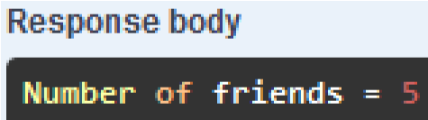

**POST API for /api/Friend**

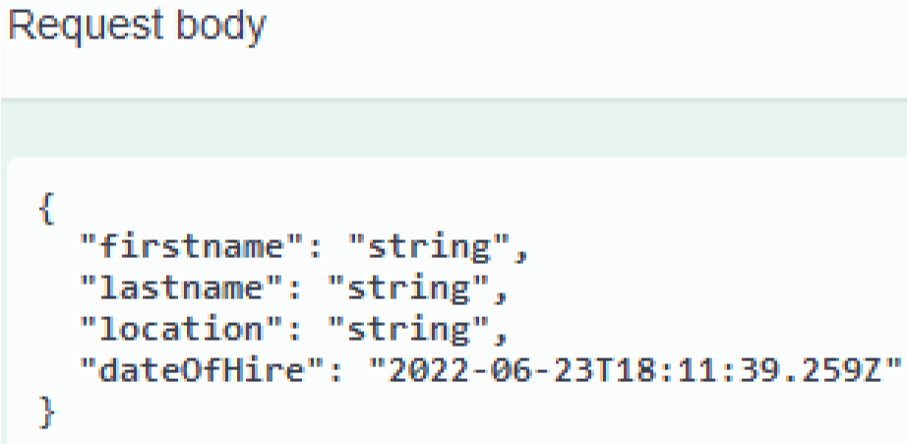

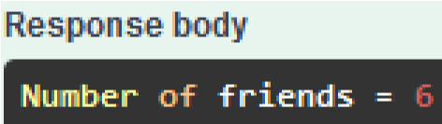

**Get API for /api/Friend/{id}**

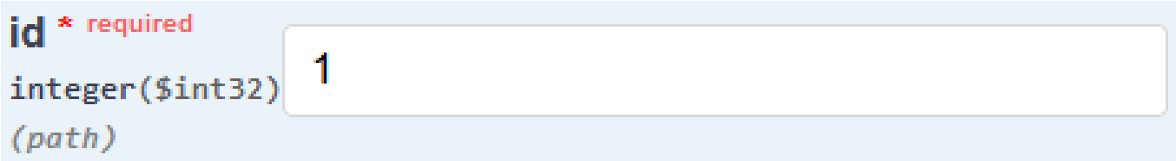



**PUT API for /api/Friend/{id}**

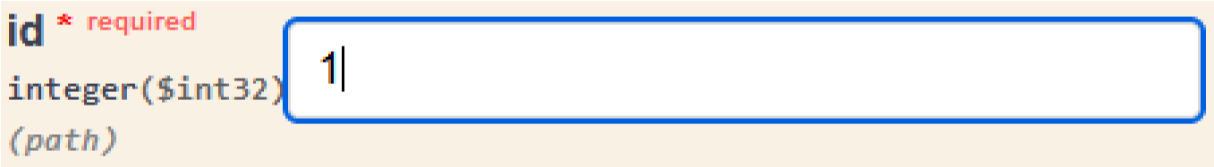

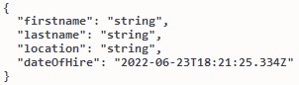

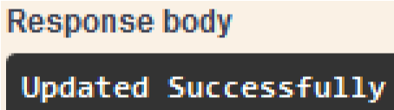

**DELETE API for /api/Friend/{id}**



